
Manager Training
How does a new employee apply to work at Smith Dairy Queens?

- Walk-in to the Restaurant and complete a manual application
  - Walk-in to the Restaurant and complete an application on the tablet on the Careers Page online. Follow the Icon bookmarked on your Google Chrome web browser
- DQ Careers Page by searching for
  - https://www.smithdq.com/
    - Work at DQ
      - Careers List
        - Your location, choose position

- Seasoned App
- 
- QR Code in the restaurant (directly pulls up the location’s ad on Seasoned)
- 

New Hire Process
Regardless of where the applicant applies, (except for walk-ins) the application will come through your Seasoned app. The applicant will select an interview time through the app based on your interview availability.
- Meet/interview candidate
- Once the interview is complete, you must resolve the interview within your Seasoned app. OFFER Job This step will trigger a text or email to go to the applicant asking them to fill out the full application. Click

Once “Offer Job” is selected on your seasoned app, the applicant will receive a text message or email that looks like the one below.

The applicant MUST fill out the application (additional information) to move through the process and receive their onboarding invitation.
The text or email that the employee will receive looks like this:
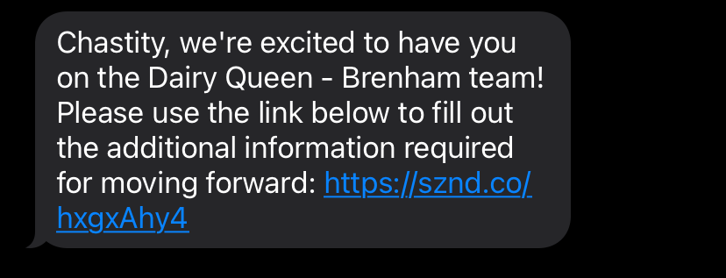

The link in the text message will take them directly to the SDQ careers page and they will click  complete the application and click 

During this step, we capture their full information, and they must answer the background questions.

Once the application is submitted, the onboarding invitation automatically goes out.

Additional Notes:

- During the onboarding, they will have to enter an emergency contact. This is required, so let them know so they are prepared before they get started.
- The onboarding goes much smoother if they complete it in one sitting. We have had a lot of issues with new hires getting locked out because they stopped filling out their onboarding and tried to go back later to finish.
- Make sure you are sending in 2 forms of unexpired identification with the new hire’s rate of pay and position. The onboarding will NOT be processed and finalized without IDs!

- Next, you will send an email to HR to provide details about the new hire offer and you MUST include 2 forms of Identification:
Email goes to: Chasity.jernigan@smithdq.com
Interview Date:
Job Title:
Rate of Pay:
Start Date: (ASAP is not an answer and same day start must be approved in advance by HR)
Collect the applicants I9 Documents A.K.A 2 forms of ID. One from List A OR one from List B AND List C (See attached list)
IF 2 forms of unexpired identification are NOT received, the onboarding will NOT be processed, and the new hire cannot start working.

Background questions are reviewed at this time and if the decision is made that the applicant is not hired, you will be notified by HR.
Notes:
    - Don’t send Ids from your personal Cell phone/device
    - Verify email address (icloud emails give issues)
    - If the applicant has had a previous Paycor account, there might be issues with making a new account
    - Verify Ids (see list of acceptable Ids) Nothing can be expired!!!!
    - Perm resident card scan front & back
    - Passport card scan front & back
    - Out of state ID scan front & back

LISTS OF ACCEPTABLE DOCUMENTS

All documents must be UNEXPIRED
Employees may present one selection from List A
or a combination of one selection from List B and one selection from List C.
LIST A  Documents that Establish Both Identity and Employment Authorization | OR | LIST B LIST C  Documents that Establish Documents that Establish Identity Employment Authorization  AND
1. U.S. Passport or U.S. Passport Card |  | 1. Driver's license or ID card issued by a State or outlying possession of the United States provided it contains a photograph or information such as name, date of birth, gender, height, eye color, and address | - A Social Security Account Number card, unless the card includes one of the following restrictions:  - NOT VALID FOR EMPLOYMENT  - VALID FOR WORK ONLY WITH INS AUTHORIZATION  - VALID FOR WORK ONLY WITH DHS AUTHORIZATION
2. Permanent Resident Card or Alien Registration Receipt Card (Form I-551)
3. Foreign passport that contains a temporary I-551 stamp or temporary I-551 printed notation on a machine- readable immigrant visa
 |  | 2. ID card issued by federal, state or local government agencies or entities, provided it contains a photograph or information such as name, date of birth, gender, height, eye color, and address
4. Employment Authorization Document that contains a photograph (Form  I-766) |  |  | 2. Certification of report of birth issued by the Department of State (Forms DS-1350, FS-545, FS-240)
 |  | 3. School ID card with a photograph
- For a nonimmigrant alien authorized to work for a specific employer because of his or her status:  - Foreign passport; and  - Form I-94 or Form I-94A that has the following:  - The same name as the passport; and  - An endorsement of the alien's nonimmigrant status as long as that period of endorsement has not yet expired and the proposed employment is not in conflict with any restrictions or limitations identified on the form. |  | 3. School ID card with a photograph | 3. Original or certified copy of birth certificate issued by a State, county, municipal authority, or territory of the United States bearing an official seal
 |  | 4. Voter's registration card
 |  | 5. U.S. Military card or draft record
 |  | 6. Military dependent's ID card
 |  | 6. Military dependent's ID card | 4. Native American tribal document
 |  | 7. U.S. Coast Guard Merchant Mariner Card | 4. Native American tribal document
 |  | 7. U.S. Coast Guard Merchant Mariner Card | 5. U.S. Citizen ID Card (Form I-197)
 |  | 8. Native American tribal document | 6. Identification Card for Use of Resident Citizen in the United States (Form I-179)
 |  | 9. Driver's license issued by a Canadian government authority
 |  | For persons under age 18 who are unable to present a document listed above: | 7. Employment authorization document issued by the Department of Homeland Security
6. Passport from the Federated States of Micronesia (FSM) or the Republic of the Marshall Islands (RMI) with Form I-94 or Form I-94A indicating nonimmigrant admission under the
Compact of Free Association Between the United States and the FSM or RMI
 |  | 10. School record or report card
 |  | 11. Clinic, doctor, or hospital record
 |  | 12. Day-care or nursery school record

Refer to the instructions for more information about acceptable receipts.

  - E-verify
    - Everyone gets processed through E-verify to establish Identity and authorization to work in the U.S. (I9)
    - Tentative nonconfirmation-Employee has 8 business days to resolve. Letter issued in English and Spanish. Must be discussed privately with the employee.
    - Employees must choose to resolve or not. No resolution=termination

Paycor Onboarding
Applicant completes the new hire onboarding process by registering and completing the onboarding steps. The system will not let them SUBMIT unless all steps are complete. It works best if they do all of this on the tablet at the store in one sitting, but they can do it from home.
How do I know they are hired and ready for work? You will receive an email from HR letting you know the POSI/BRINK number and that they are active in Paycor. They cannot start until they have a POSI/BRINK number. (Their BRINK PIN is the SAME as their PAYCOR employee ID number)
Call or email HR with any questions!!! Tell your new hires to contact Chasity if they need help. 979-846-2222-X2300
What will the applicant see when they receive the invite?
In their email INBOX they will receive an email from Paycor:
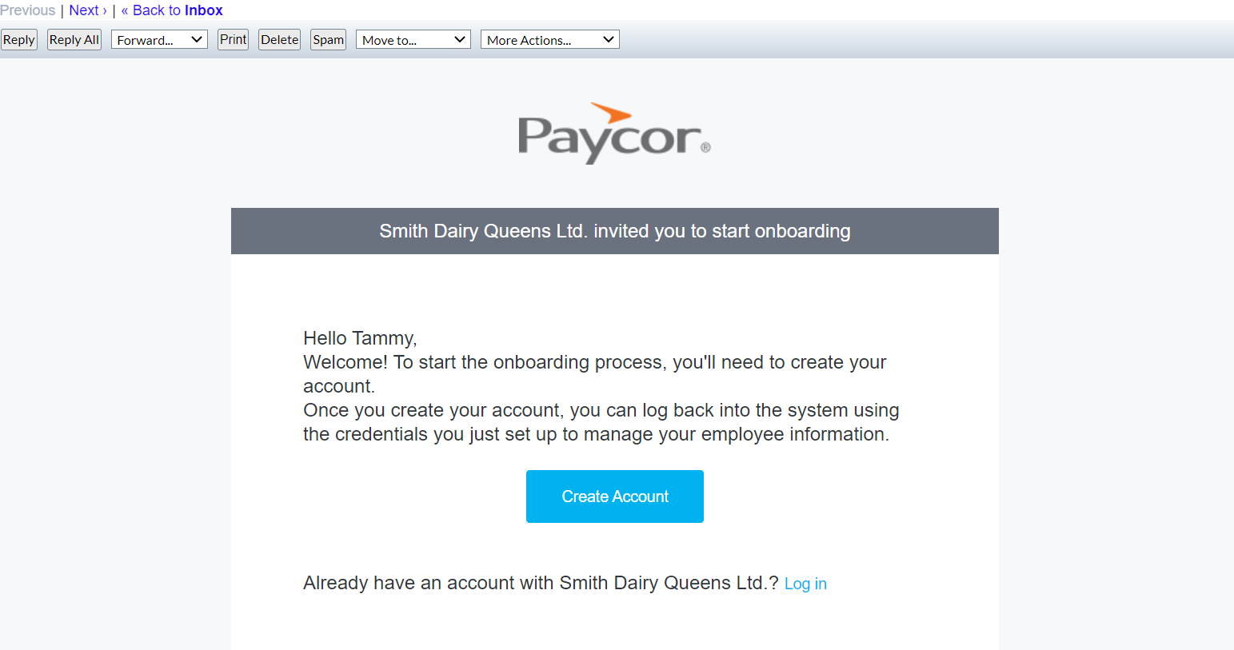

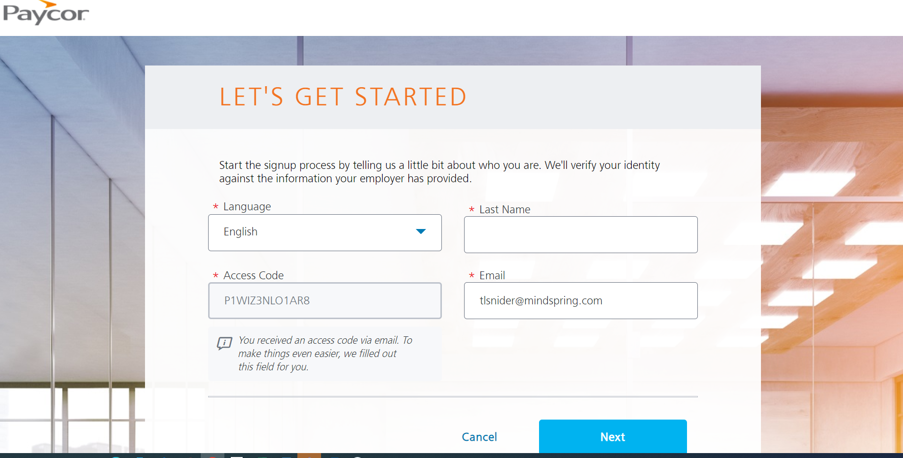

***The applicant can choose their language… English, Spanish or French***

Select authentication method
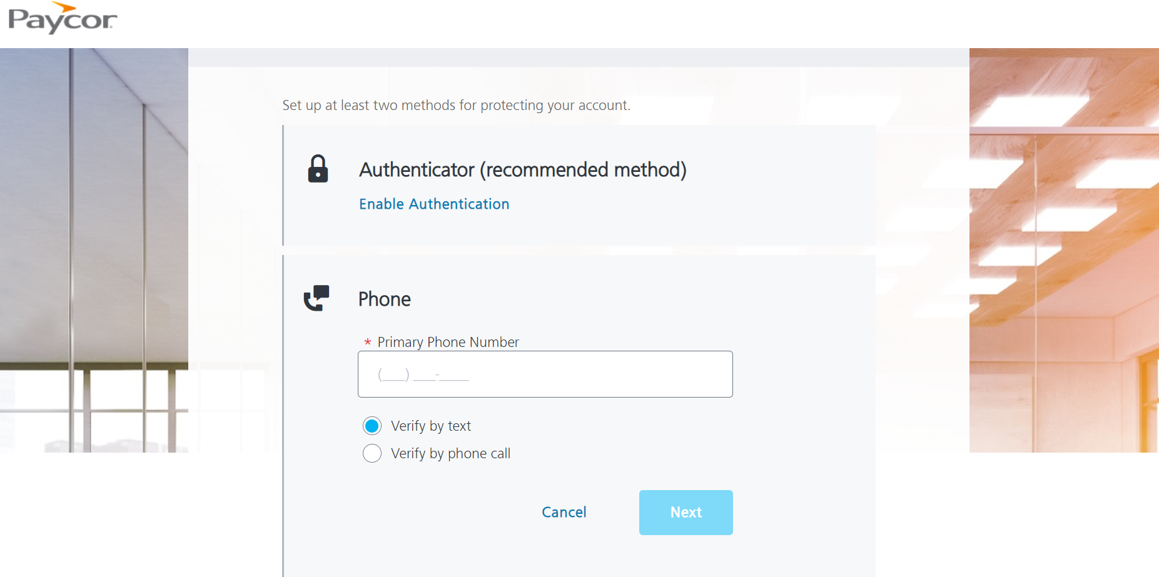

Setup security Questions
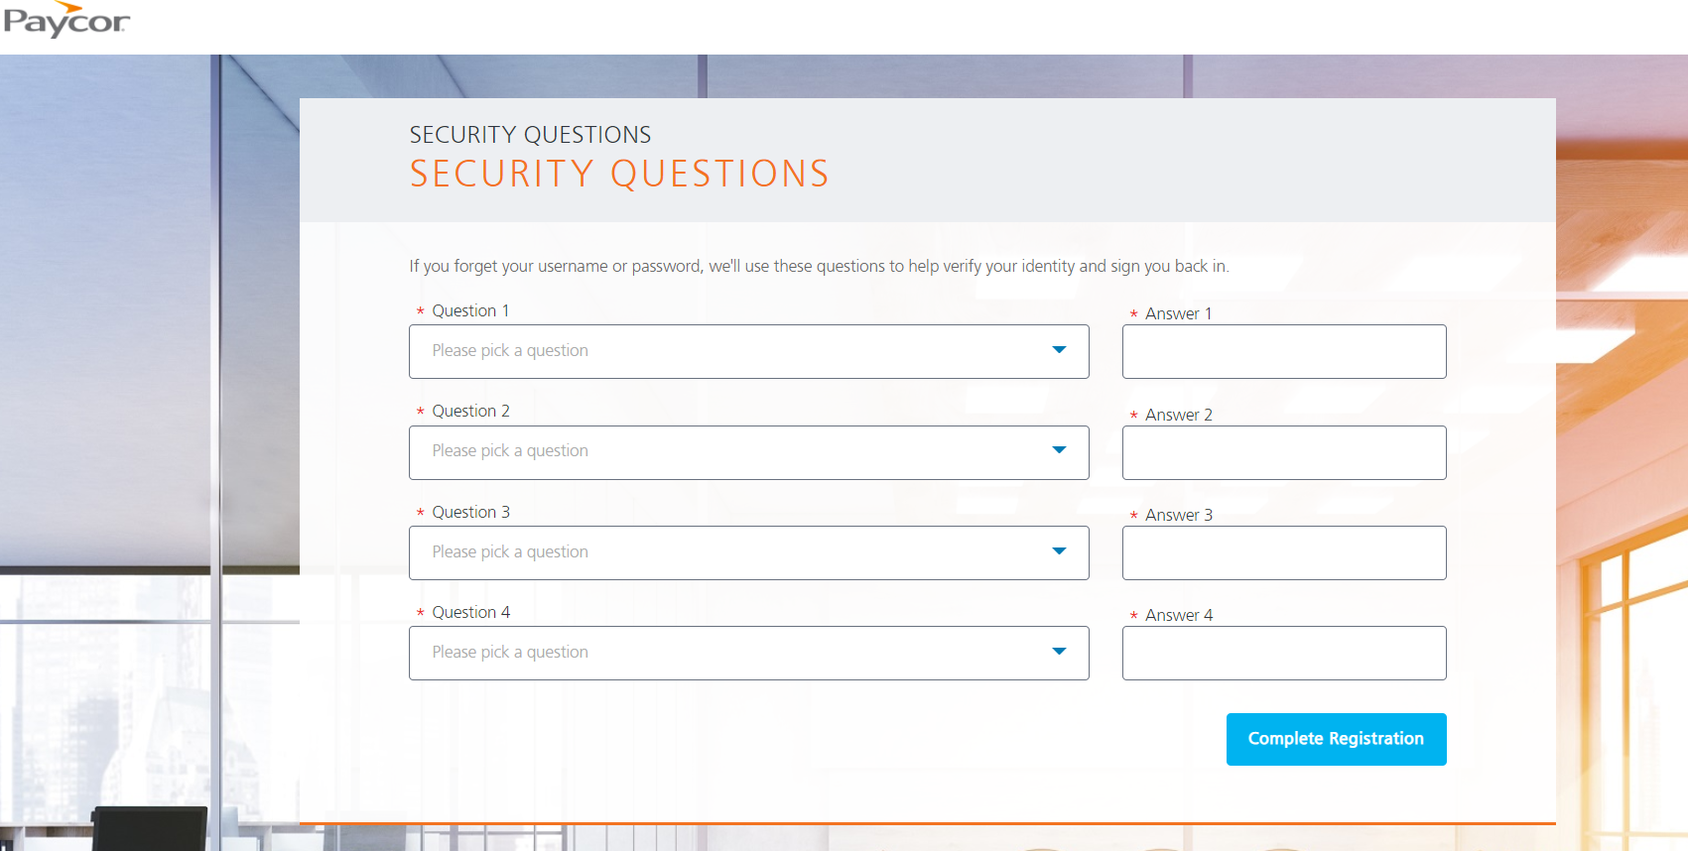

Once they click “Complete Registration”, they will be taken to the login screen. They will use their newly created username and password to enter.
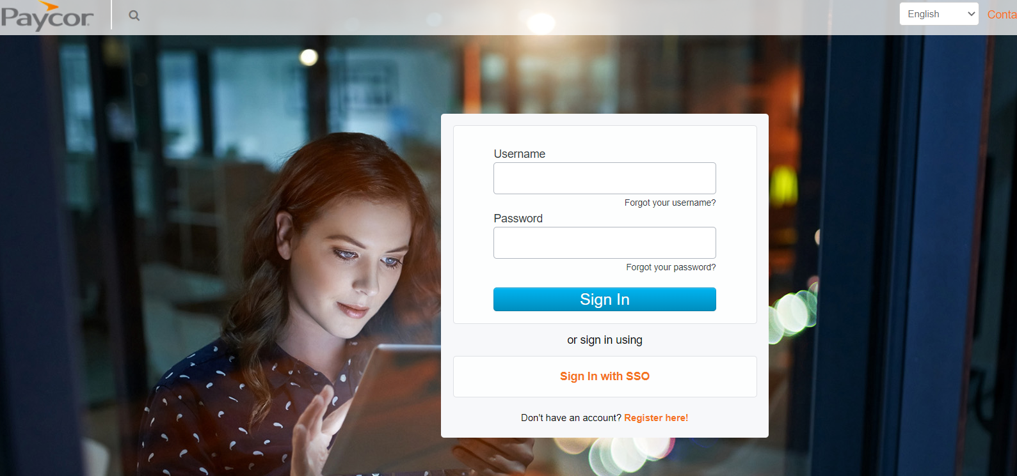

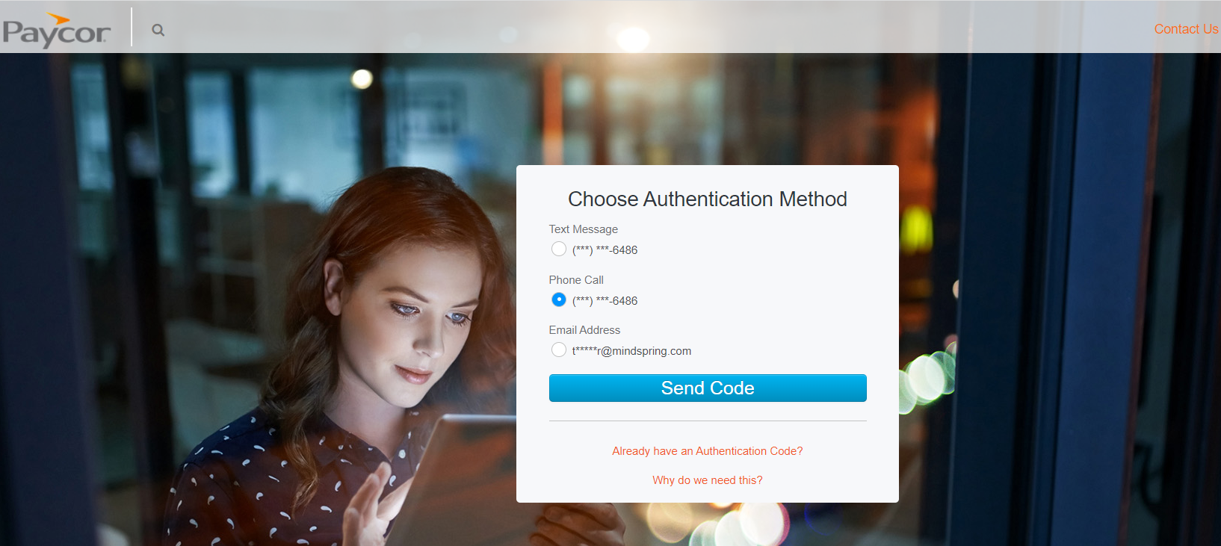

The applicant will have to choose an authentication method and click “SEND CODE”. Whatever method you choose, you will receive a code, and you will need to enter it and click SUBMIT.

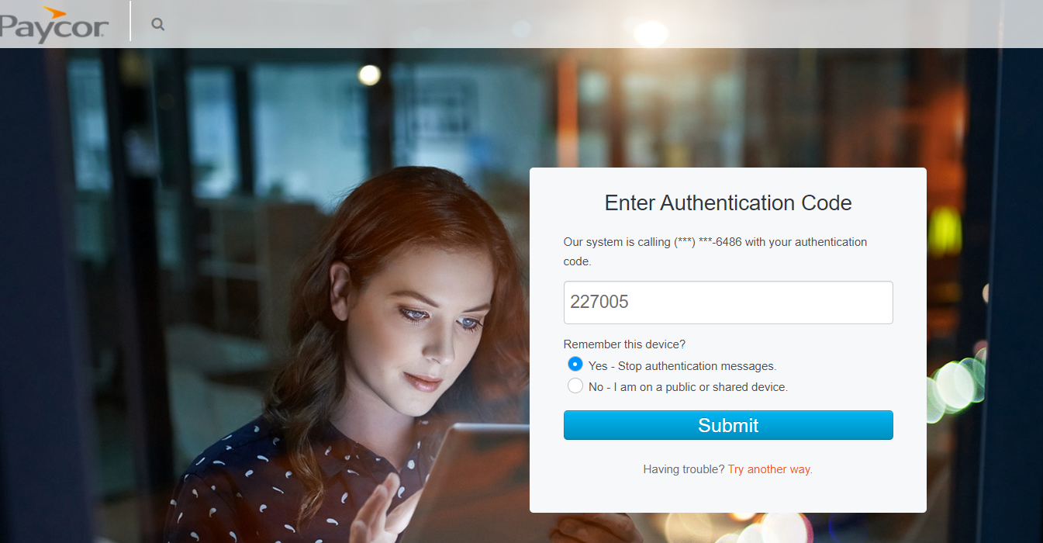

Congratulations! They have successfully registered and can now complete the onboarding!! Once they are done and click submit, their file will be under review and then you will be notified when they are active in Paycor and POSI and ready for work!
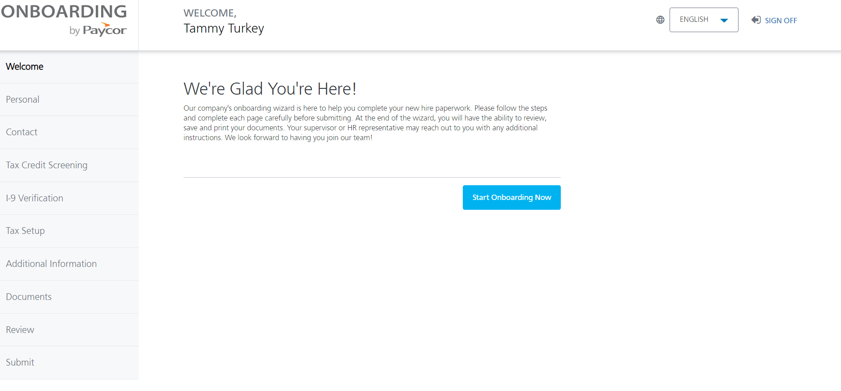
HR cannot process the file until the applicant clicks “SUBMIT”

What can I see and do as a Manager?

Main Dashboard-
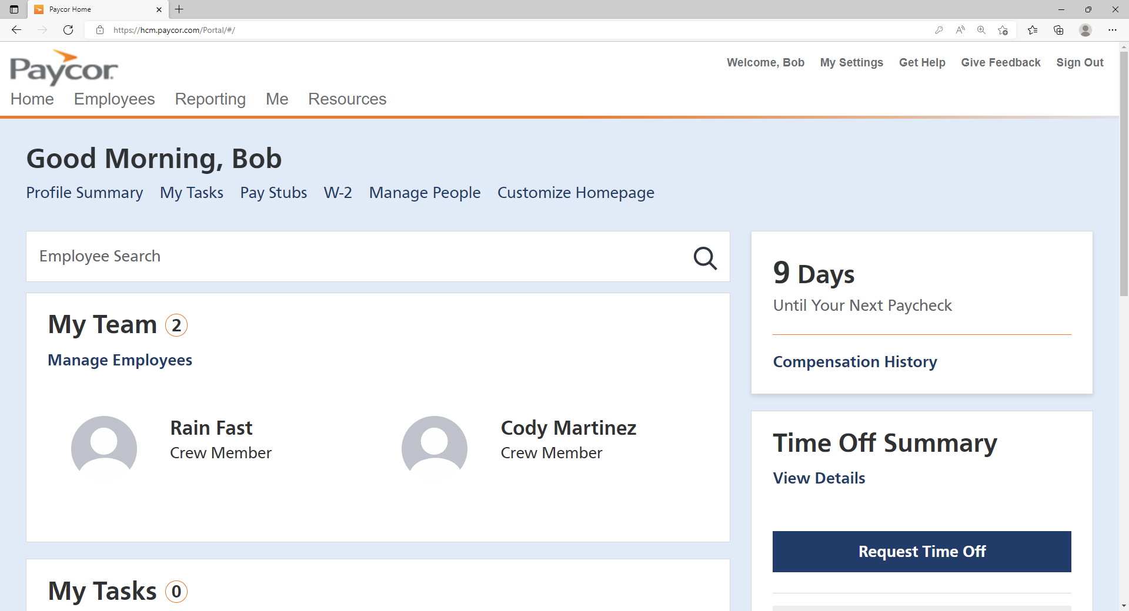
- To view your information click ME or Profile Summary
- To view your location’s team members, click Manage People or Employees>Manage Employees

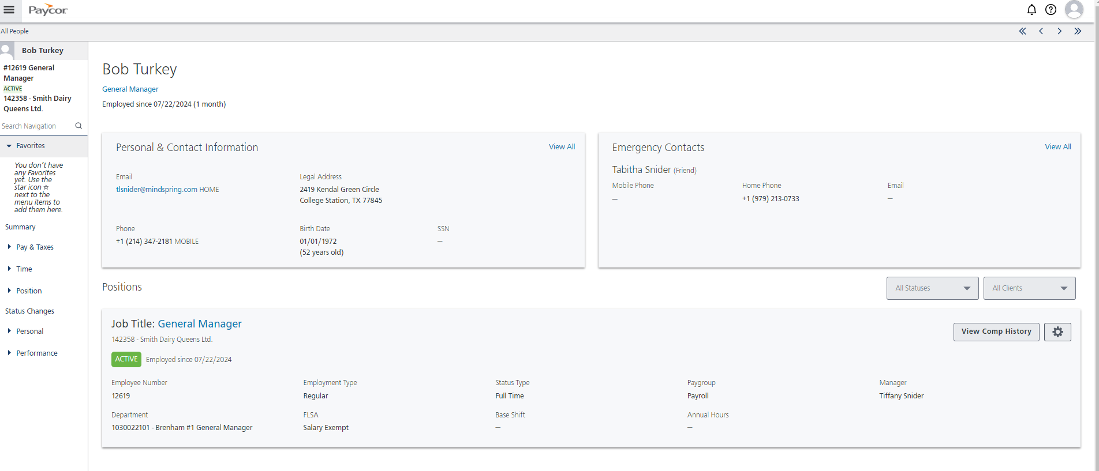
Your information is displayed as above and can be viewed by clicking Profile Summary or Me

When you click Manage Employees you will see a listing of employees at your location.
Stores that have an Assistant Manager will see that their employees are showing the AM as the Manager. This allows the AM to have access to the employees and allows the GM to have access.
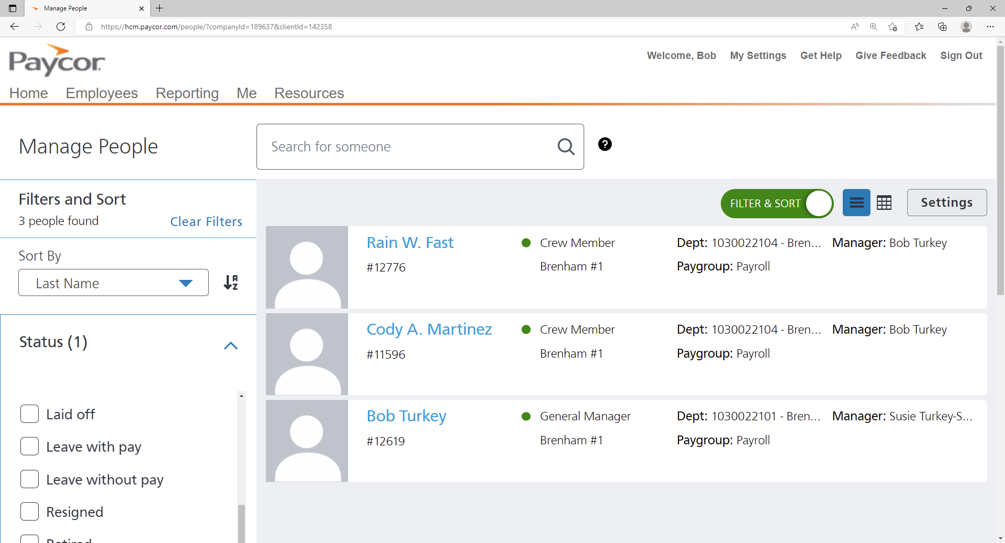

- To view a specific employee click on their name
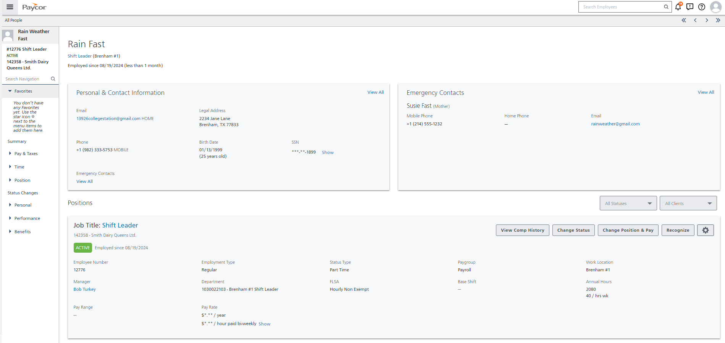

- View employee Contact information and Emergency Contacts-Personal>Personal Info
- Employees can Edit contact information and Add emergency contacts
(You don’t have access to view Identity information SS#, date of birth)

View/add documents Position>Documents
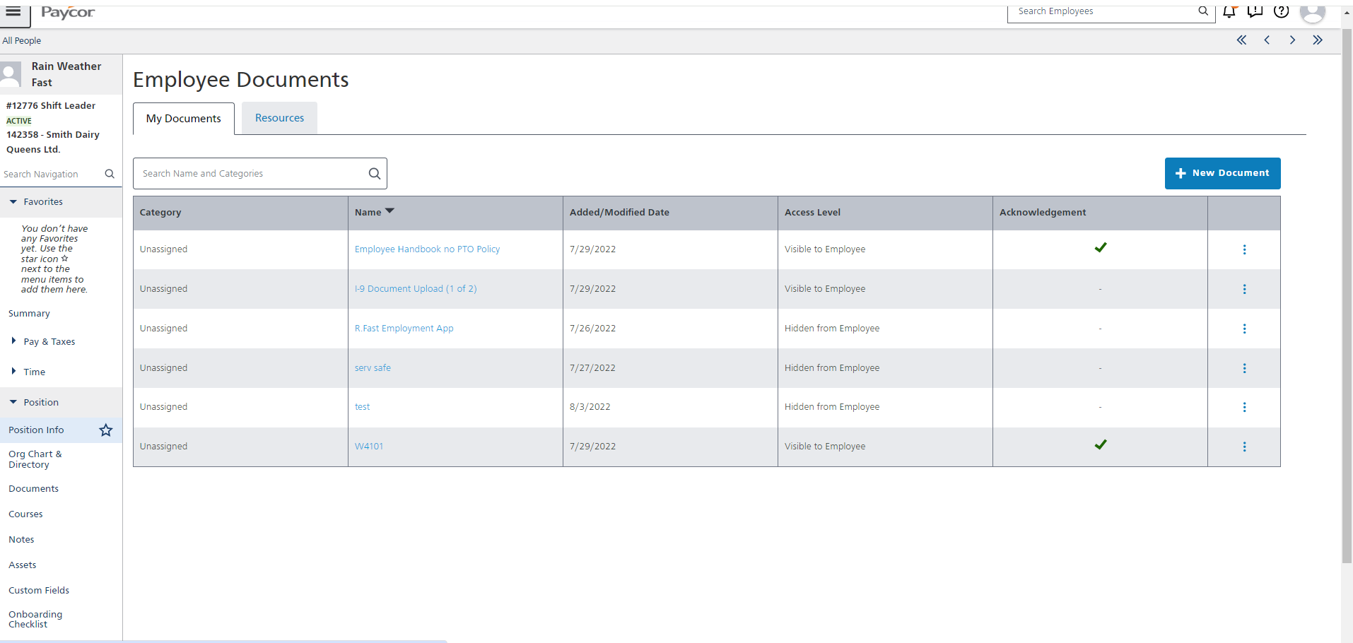
View position and initiate position change
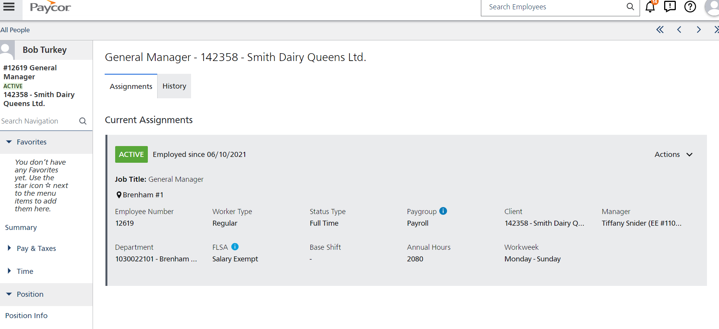

- To initiate a position change and Pay Change

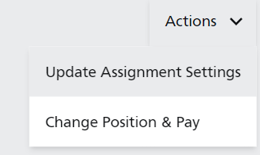

  - Enter Effective Date (must ALWAYS use the START of a pay cycle) and Notes
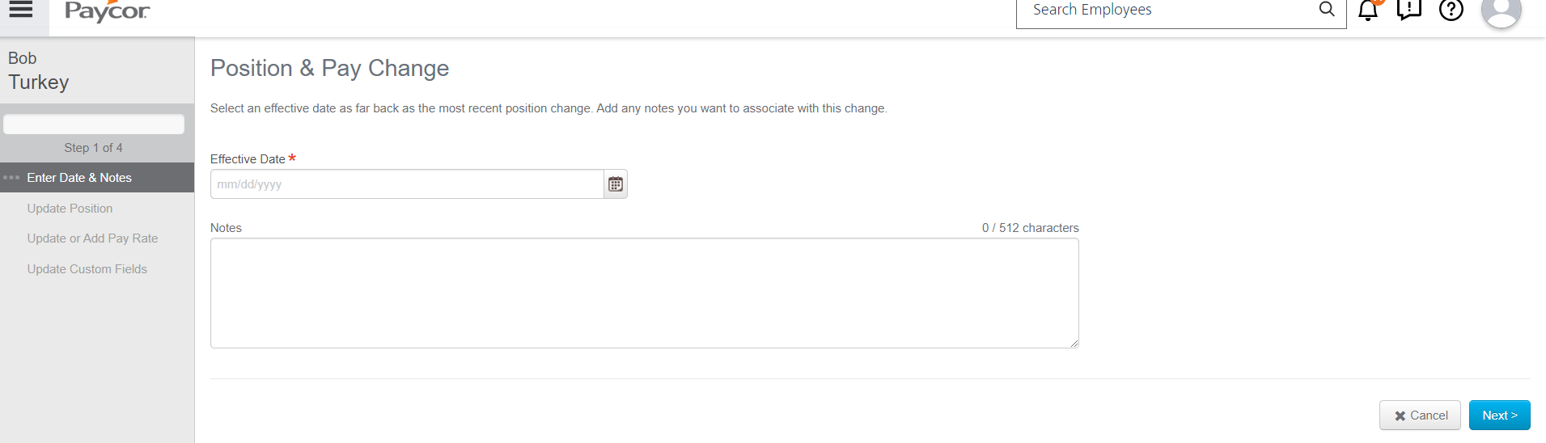

You will be taken to the following screen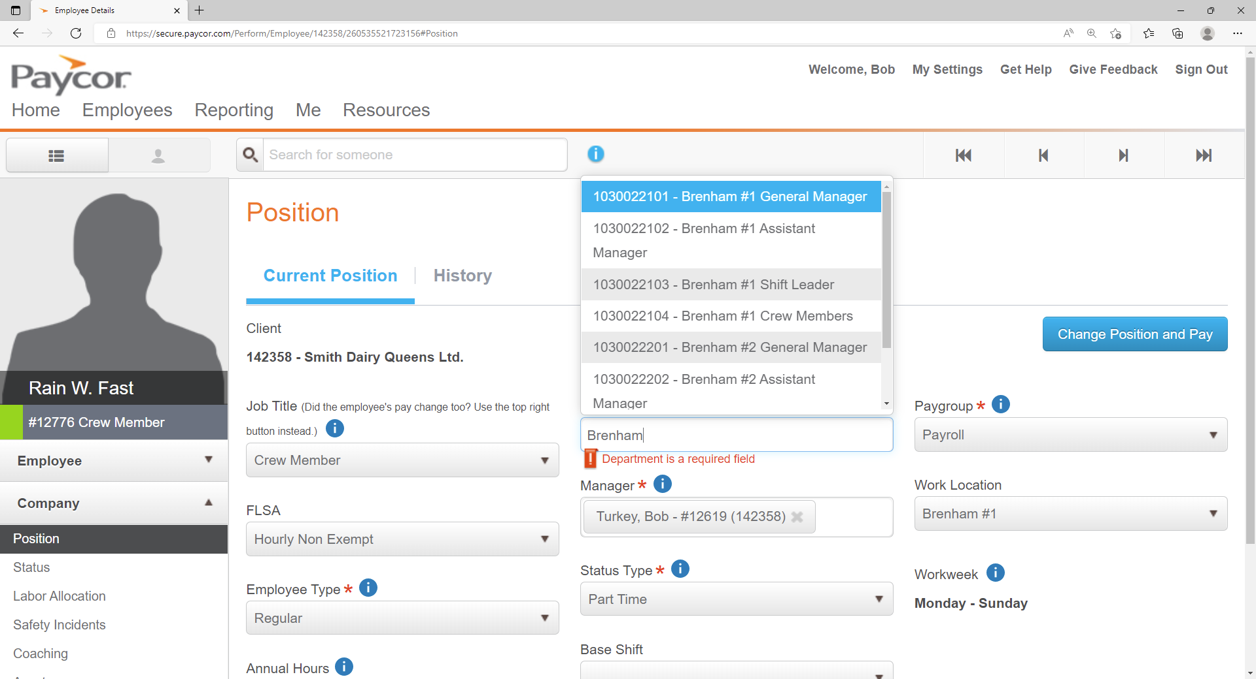

  - Edit Job Title
    - Crew Member
    - Shift Leader
    - AM
    - GM
  - Edit Department
    - X old Department
    - Find new department by typing location name and select appropriate position
- Click NEXT when you are finished
You will be taken to the Pay change Screen. If you are changing position only, then click next. If you are changing pay rate then use the PENCIL Icon to edit the pay rate:
NEVER EVER CLICK ADD PAY RATE!
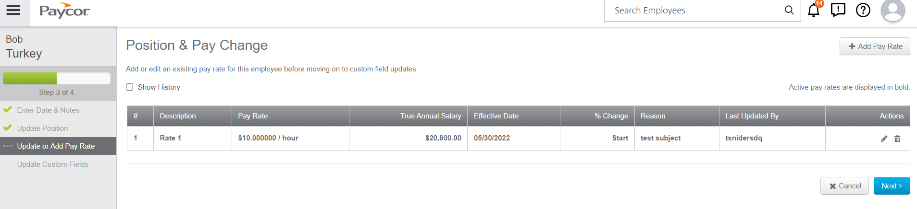

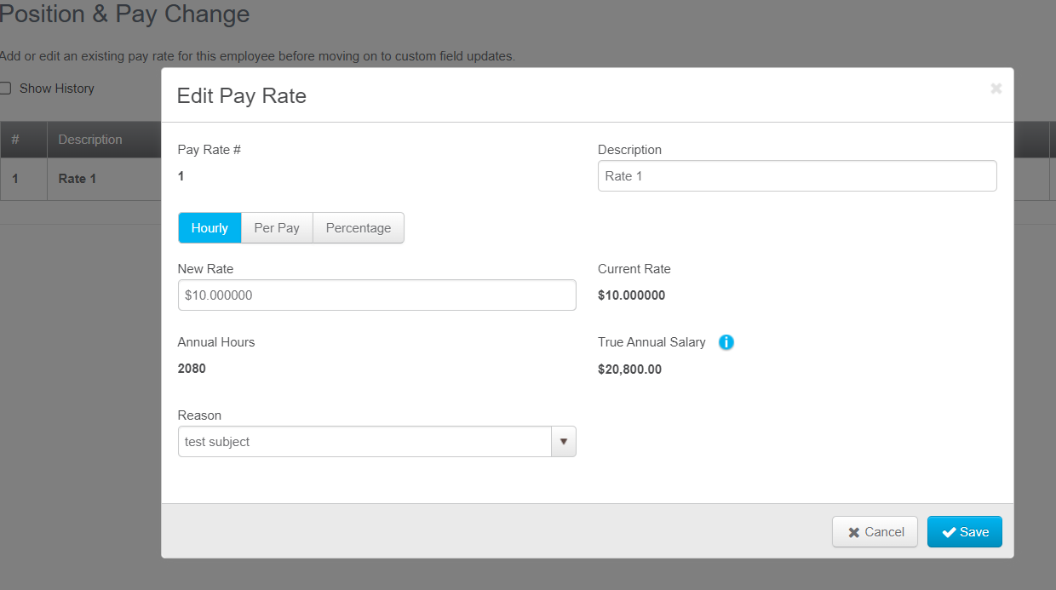
Enter the new pay rate and a reason… Merit, Promotion, etc. Click SAVE. It will take you back to the pay rate change screen and click NEXT, then Save/FINISH on the Custom Fields page. (there is nothing to enter here at this time.)

View status and initiate status change (termination)
- Select “Status Changes” tab.
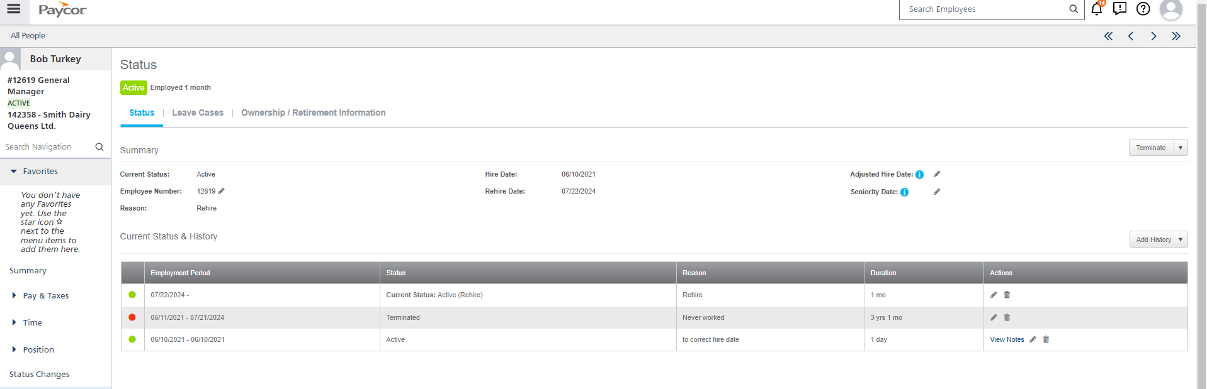
- To terminate an employee, select “Terminate” button on the far right.
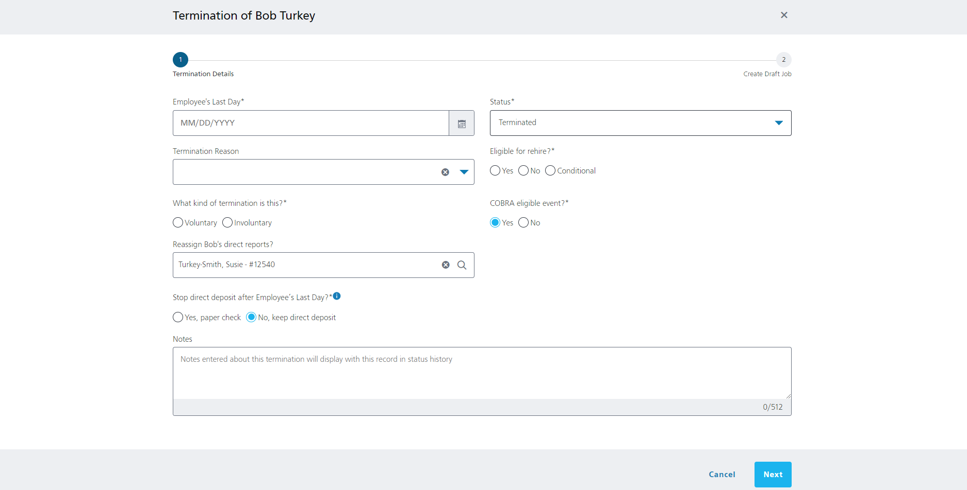
- Enter the “Employee’s Last Day” in the calendar.
- Select the “Status” under the drop-down options. Use Terminated for all
- Select the “Termination Reason” under the drop-down options. Use the correct reason (these are not the only reasons)
  - Quit to Work Elsewhere
  - Resigned
  - Insubordination
  - Job Abandonment
- Select if employee is “Eligible for rehire?”.
- Select “What kind of termination is this?”.
- Select if this is a “COBRA eligible event?”. Yes is always the answer
- Select whether to “Stop direct deposit after Employee’s Last Day?” Yes is always the answer
- Add any additional “Notes” in the text box. Objective notes only. No negative comments or stick to the facts
- If you have any statements or a termination form add to the Documents Section of their profile
- NEXT
- The system will ask if you want to add this job to the ATS. No is the answer every time.
- Submit Termination

